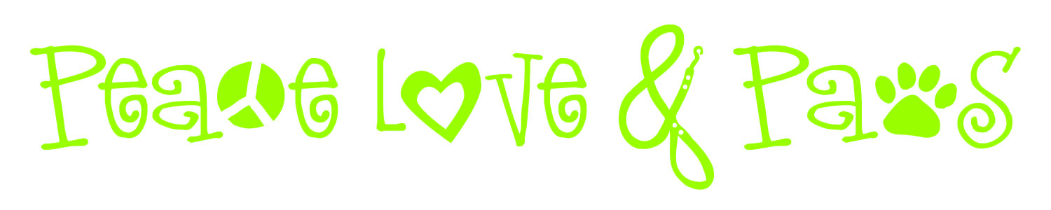
Policies and Procedures
For the purposes of this document, the terms Client, Owner and Pet Owner are synonymous with the person contracting services for one or more animals. A signed Service Agreement must be provided before service is provided for any period.
Payment: Payment is due in full upon completion of service period unless special arrangements have been made before service begins. Preferred forms of payment are cash, check and money orders. Peace Love and Paws will add $25 plus bank fees for any returned check. Although not required, if you wish to tip the pet care provider, please write a separate check in the pet care provider's name or leave cash for your pet care provider.
Confirmation Call: (Prior to out-of-town departure): Client will make a confirmation call no less than 24 hours before each departure in order to verify all information (dates, contact numbers, etc) is still correct. Since phone mail messages and emails are not 100% reliable, please make sure we speak personally or email is acknowledged by Peace Love and Paws to ensure your pet's needs are carried out as intended.
Cancellation Policy: We understand your plans change and we generally do not charge for cancellations with adequate notice. However, if you cancel 24 hours or less prior to the date of the first visit, there will be a $25 cancellation fee.
Reliability: Peace Love and Paws agrees to provide the services stated in this agreement in a reliable, caring and trustworthy manner. In consideration of these services, the Client expressly waives and relinquishes any and all claims against Peace Love and Paws, except those arising from negligence or willful misconduct on the part of Peace Love and Paws.
Keys: Two working copies of your house keys must be provided before start of service. If you live in a gated community, you must provide a gate card, remote control or appropriate access code. No keys will be returned by regular mail, hidden outdoors or locked in homes at last visit. If you choose not to have Peace Love and Paws retain a key for future services, there will be a $10 charge per trip for time and mileage. A second option for key return is via U.S. certified mail. To cover costs, the charge for this option is $5.
Outside Access: At the time service is booked, owner will notify pet sitter of everyone who has been granted access to the home during the service period. Peace Love and Paws accepts no responsibility for security of the premises if other individuals have access to a client's home or if home is not properly secured.
Damages: Peace Love and Paws is not responsible for damage to the home beyond their control such as structural damage of the home or acts of nature. In these situations, Peace Love and Paws will attempt to contact the Client and/or designated emergency contact prior to a subjective decision on resolving any such issues. All repairs and related fees will be paid by the client or filly reimbursed to Peace Love and Paws within 14 days.
Loss and Damage: Peace Love and Paws in not liable for any loss or damage due to burglary or other crime that should occur while under this contract. Pet Owner agrees to secure home prior to leaving the premises, and pet sitter will re-secure home at the end of each visit. While keys are in the possession of Peace Love and Paws, they will be either on pet sitter's physical person or properly secured in key safe.
Pet Proofing: Pet owner is responsible for pet-proofing house and yard, security fences, gates and/or latches. Peace Love and Paws will not be responsible for the safety of any pets or liable for the death, injury, disappearance, or legal consequences of any pet with unsupervised access to the outdoors.
Animal Emergency: I authorize Peace Love and Paws to transport my pet(s) to a veterinarian in the event of their illness or injury and authorize treatment deemed necessary by the veterinarian. In the event the pet is in need of hospitalization; Peace Love and Paws is authorized to leave the pet until the pet can be transported home. If at-home medication is prescribed, Peace Love and Paws has my permission to administer the directed dosage. If Peace Love and Paws incurs any medical expenses for the pet's treatment, I will reimburse that amount plus transportation fees, if applicable.
Vaccinations: All pets in the care of Peace Love and Paws MUST be current on all vaccinations prior to service period. Should the pet care provider of Peace Love and Paws be bitten or otherwise exposed to any disease or ailment received from the client's pet which has not been properly vaccinated, it is the Client's responsibility to pay all costs and damages incurred by the victim.
Supplies/Equipment: Pet Owner is responsible for supplying the necessary supplies/equipment needed for the care of their pet(s) including but not limited to a well-fit harness or collar, firmly affixed vaccination tags, leashes, litter boxes, food, cleaning supplies, medications, litter, etc. Pet Owner authorizes any purchases necessary for the satisfactory performance of duties. Pet Owner agrees to be responsible for the payment of such items, as well as service fees for obtaining items and will reimburse Peace Love and Paws within 14 days for all purchases made.
Client Return: Client must notify Peace Love and Paws when you have returned home. If you do not call and do not answer your phone, we will make additional visits at the expense of the pet owner.
Injury: Pet owner will be responsible for all medical expenses and damages resulting from an injury to the pet sitter, or other person(s), by the Pet. Client agrees to indemnify, hold harmless, and defend Peace Love and Paws, in the event of a claim by any person injured by the Pet.
Terminate Service: Peace Love and Paws may use their discretion to end service at any time that a pet poses a danger to the safety or health of itself, other pets or people. If concerns prevent the Pet Sitter from continuing pet services, Owner authorizes the pet(s) to be placed in a kennel or previously arranged locale if possible. All subsequent charges, including but not limited to transportation, kenneling, tranquilizing, treating, accessing, and liability are to be the responsibility of the Owner.
Concerns: Client agrees to discuss any concerns with Peace Love and Paws within 24 hours of return after service.
Agreement: This agreement is valid from the date signed. Client agrees to any future Peace Love and Paws term changes relayed verbally to the Client, mailed, or emailed in writing to the Client or posted on or website. This agreement may be terminated by either party by giving 30 days written notice to the other party.
Contract: This contract permits Peace Love and Paws to accept all future telephone, online, mail or email reservations and provide service without additional signed legal agreements.
Terms and Conditions: The Client/Owner states that he/she has read this agreement in its entirety and fully understands and accepts its terms and conditions.

I, _______________________________, have read, understand and agree to the pet care policy of Peace Love and Paws Pet Sitting. All policies and guidelines are subject to change at Peace Love and Paws Pet Sitting's discretion.

