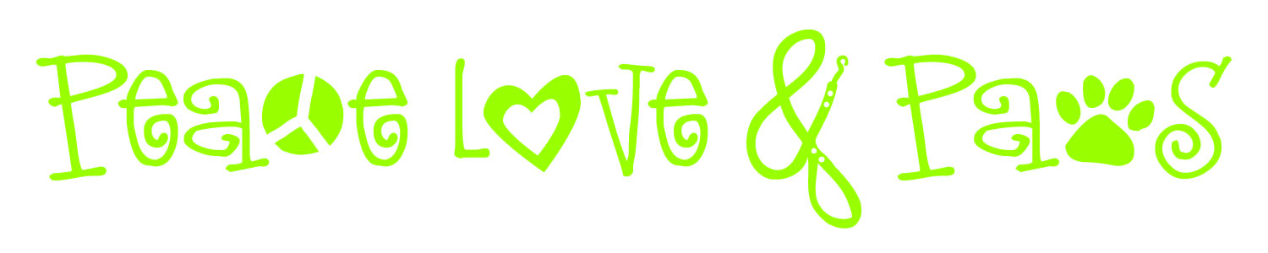
Pet Profile
Pets Name:___________________ Age:________ Gender:__________________________________________
Breed:____________________________________ Color(s)____________________________________________
Spayed/Neutered: Y / N Tags: Y / N Microchip: Y / N
Feeding
What brand(s) and/or types of food do you feed:________________________________________________________
Feeding Instructions (amount, times of day, etc)_________________________________________________________
_____________________________________________________________________________________________
Dispose of uneaten food: Y / N
Any special treats:_______________________________________________________________________________
Dietary Constraints/Allergies:______________________________________________________________________
Special Needs and Medications
Any special needs:_______________________________________________________________________________
Medical conditions:_______________________________________________________________________________
Medications:___________________________________________________________________________________
Reason for medication:____________________________________________________________________________
Where is medication kept:_________________________________________________________________________
When and how often is it given:_____________________________________________________________________
How is it administered:____________________________________________________________________________
Where does medication come from:__________________________________________________________________
Behavior
Any unusual behaviors/tricks:____________________________________________________
How does this pet get along with other animals/people:_________________________________
Favorite toys and games:________________________________________________________
Likes / Dislikes:______________________________________________________________

Exercise
What type of exercise is preferred:__________________________________________________________________
How often and for how long/normal routine:____________________________________________________________
Miscellaneous
Restricted access (rooms or furniture)________________________________________________________________
Hiding places:___________________________________________________________________________________
Crating instructions:______________________________________________________________________________
Litter care (when to scoop solids/change schedule disposal location___________________________________________
_____________________________________________________________________________________________
Special handling/Other notes: (ex: quirks, deaf/blind, food aggression, object guarding, storm anxiety, separation anxiety, fears/phobias, etc)
_____________________________________________________________________________________________
_____________________________________________________________________________________________
_____________________________________________________________________________________________
Locations Please tell me where you will keep the following items during visits and any applicable instructions:
Food/Bowls:____________________________________________________________________________________
Leash/Harness:_________________________________________________________________________________
Litter Box/Litter:_______________________________________________________________________________
Treats:_______________________________________________________________________________________
Crate:________________________________________________________________________________________
Pet Carriers for transport:_________________________________________________________________________
Pet towels:_____________________________________________________________________________________
Cleaning supplies/Rags:____________________________________________________________________________
Extra paper towels:______________________________________________________________________________
Vacuum cleaner/Broom/Dustpan:_____________________________________________________________________
Main indoor trash can/Trash bags:___________________________________________________________________
Garbage Can/Recycle Bin:__________________________________________________________________________
Where to dispose of waste:________________________________________________________________________
Thermostat:____________________________________________________________________________________
Main Water Shut Off Valve:________________________________________________________________________
Circuit Breaker Box:______________________________________________________________________________
Gas Shut Off Valve:______________________________________________________________________________
Fire Extinguisher:_______________________________________________________________________________
Extra Light Bulbs:_______________________________________________________________________________

Extras
Indoor/outdoor plant watering directions:___________________________________________
__________________________________________________________________________

Alter Lights/Blinds: Y / N
Turn on TV/Radio: Y / N

Do you mind if Peace Love and Paws photographs your pet(s): Y / N
May we post the pictures on our website: Y / N

